**CH 245: ORGANIC CHEMISTRY I LABORATORY (Fall 2019)**

**Title:**

1. **Purpose: (1 point)**

**To synthesize methyl m-nitrobenzoate from methyl benzoate and purify crude compound with recrystallization.**

1. **Drawing of structure of the main compound or balanced chemical equation if synthesis is performed: (1 point)**

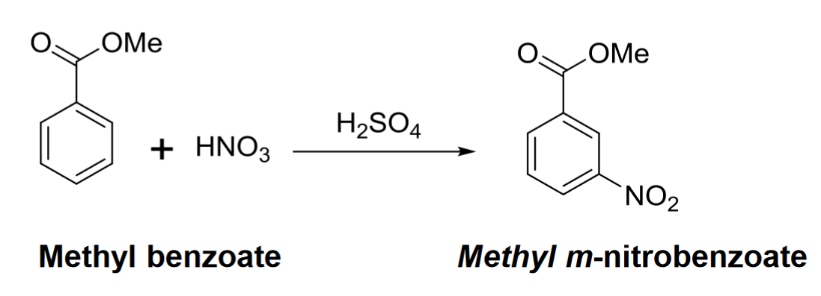

**3. Reagents and the major product (up to 5 points)**

|  |  |  |  |  |  |  |
| --- | --- | --- | --- | --- | --- | --- |
| **Name** | **M.W.**  (0.5 pts) | **Density**  (0.5 pts) | **Amount (grams/mL)**  (0.5 pts) | **Moles**  (0.5 pts) | **Hazards/Precautions**  **(MSDS data) and melting point or boiling point** (2 pts) | **Role of the reagent\*** (1 pts) |
| Methyl Benzoate | 136.15 | 1.080 g/cm3 | 1.4 grams / 1.3 mL | 0.010 | Combustible, harmful if swallowed | Reactant |
| Nitric Acid | 63.02 | 1.40 g/cm3 | 1 mL | 0.022 | Corrosive, eye damage, respiratory irritation, organ toxicity. | Reactant |
| Sulfuric Acid | 98.07 | 1.840 g/cm3 | 4 mL | 0.075 | Very strong acid, corrosive, eye damage, respiratory irritation, organ toxicity. | Catalyst |
| Methanol | 32.04 | 0.791 g/cm3 | 2 mL | 0.049 | Flammable, toxic, fatal or cause blindness if swallowed. | Solvent/  Washing |
| Methyl  m-nitrobenzoate | 181.15 | 1.301 g/cm3 | 1.81 g | 0.010 | May be harmful if inhaled or swallowed. May cause skin and eye irritation. | Product |

**For Role of the reagent*, Choose from the following options:**

**Reactant, Product, Solvent, Drying agent, Catalyst**

1. **Calculations: (1 point)**

Show each calculation for moles of reagents and for theoretical and actual yield. Fill in the box with the limiting reagent and theoretical yield:

Methyl benzoate

The limiting reagent is

1.81 grams m-nitrobenzoate

The theoretical yield is

$$0.010 \text{mol methyl benzoate}*\frac{\text{1 mol m-nitrobenzoate}}{\text{1 mol methyl benzoate}}*\frac{\text{181.15 g m-nitrobenzoate}}{1 \text{mol m-nitrobenzoate}}=1.81 \text{grams m-nitrobenzoate}$$

**5. Procedure (up to 2 points)**

|  |  |
| --- | --- |
| **Procedure** | **Observations and Lab Data** |
| A summary of the procedure done with bullet points) | Color changes, exothermic or endothermic reactions, gas generation, etc.; tare weights for flasks, etc. |
| * Place 3 mL (5 g) of concentrated sulfuric acid in a 50 mL Erlenmeyer flask and add a stir bar. * Cool to 0°C, and add 1.3 mL (1.4 g) methylbenzoate, stirring. * While maintaining internal temperature of 5-15°C, add drop by drop a cold mixture of 1 mL conc. sulfuric acid and 1 mL conc. nitric acid. * Swirl/stir solution during addition for 10 min after all the acid has been added. * Pour the reaction mixture, with stirring, onto 10g of cracked ice bath to precipitate crude methyl m-nitrobenzoate. * Collect the product with vacuum suction with a Buchner funnel. * Wash the product on a filter paper with two or three 3 mL portions of water to remove acids. (Aq waste) * Wash the product with two 1 mL portions of cold methanol and dry for 5 minutes. (organic waste) * Take weight of crude product * Remove a few crystals for recrystallization and TLC. * Take crude product in 25mL Erlenmeyer flask and add 2.5 mL methanol per gram of crude product. * Add two boiling stones and heat mixture over hot plate until all solid dissolves. * Cool flask to room temperature. * Put flask over ice bath for 5 minutes. * Filter mixture using Buchner funnel and vacuum. * Wash the solid with two 1 mL portions of ice-cold methanol and allow solid to dry. * Take weight of recrystallized solid. * Prepare three small beakers. * Add methyl benzoate to first, crude product to second, and recrystallized product to third. * Add small quantity of dichloromethane to dissolve. * Take a TLC plate and add lines one cm from top and bottom. * Mark three dots with a pencil on one of the lines. * Spot each of the three compounds on the TLC plate and mark spots. * Put a mixture of 80% hexane and 20% EtOAc in the TLC bottle. * Put a filter paper in the TLC bottle. * Put the TLC plate and let the solvent run up to the top line. * Take out TLC plate and let it dry in air. * Visualize under UV lamp and mark spots. * Calculate Rf of each spot. |  |

**6.** Results; include actual yield in grams and % yield.

**Results (need to get signed by instructor or TA):**